DESIGN AND DEVELOPMENT OF A COMPONENT BY REVERSE ENGINEERING
Abdalla M Abdalla, Student , Department of Mechanical Engineering, UAE University
Salem Alzaabi, Student , Department of Mechanical Engineering, UAE University
Abdulla Al Kindi, Student , Department of Mechanical Engineering, UAE University
Supervised by Dr. Aiman Ziout, Assistant Professor,Department of Mechanical Engineering,UAE University

ABSTRACT
Reverse engineering technique involves duplication of a component, subassembly or assembly of a product for which sufficient details are not available for manufacturing and improvement of the product. In this study, reverse engineering process for a mechanical component has been discussed. The main objective of this report is to introduce the concept of reverse engineering technique for development of 3D CAD model and to obtain measurements by scanning a real life model of the machine component using 3D Scanner. In this study, a mechanical component was selected which was scanned using a 3D scanner i.e Artec Scanner to produce point cloud data. Point cloud data was obtained using Artec Studio 12 Professional. Further, point cloud data was used to develop 3D CAD model in Geomagic Design X. The 3D CAD model from Geomagic Design X can be exported in step format to use for manufacturing of the product.
Keywords- Reverse engineering process, 3D scanning, Point cloud data

INTRODUCTION
Reverse engineering technology is used for duplication, improvement or understanding the working of a product. It is most commonly used in field of product manufacturing, software industries and electronic industries.
In manufacturing industries, a product to be reverse engineered is initially scanned using a 3D scanner to generate a point cloud data. This point cloud data can be read using CAD programs or specialized CAD programs to read point cloud data such as Geomagic Design X. The point cloud data is converted to a solid body and exported generally in step format from Geomagic Design X for production purpose.

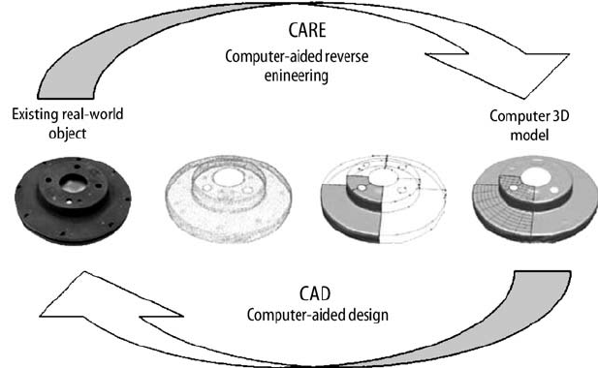
Figure 1: Reverse Engineering

LITERATURE REVIEW

V.N. Chougule et al. [1] developed an algorithm for conversion of non-invasive CT scan to free form surface. Figure 2, shows an outline of algorithm which used image processing technique and was developed to extract point cloud data from stalk of non-invasive CT scan images. DICOM 3.0 format was used for acquisition of CT scan. Edge detection method and threshold technique was used for point cloud estimation. Free form NURB surfaces were fitted to the points followed by swept blending technique for fitting surface between these curves network.
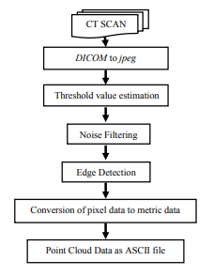
Figure 2:Methodology for generation of point cloud data [1]
Zhiliang Xia et al. [2] discussed about the application of reverse engineering using computer technology in product design. It discussed about use of CAD packages such as Solidworks and Pro/E for conversion of point cloud data to 3D CAD file which can be further used for manufacturing the product.
Antonio Piratelli-Filho et al. [3] produced free form surfaces of a sports car using reverse engineering technique. A scaled model of sports car was used which was 1/18th of the actual model. Overall dimensions of the scaled model were around 300mm X 150mm. Measurement of the model was conducted using two different method i.e contact and non-contact type. Contact type measurement was carried out through AACMM (Arcticulate arm coordinate measuring machine) and Romer model Arm 100. A rigid needle stylus probe was coupled with arm end to capture coordinates of the points on part surfaces. G-Pad was used for operation of AACMM and data points were stored in form of IGS file. NextEngine 3D DESKTOP HD model 2020i laser scanner was used for non-contact type measurements. It uses four sources of laser with 10mW each and have wavelength of 0.65micro meter. Speed of the scanner was around 50000 processed points per second and density of points were around 248 points/mm². The free form surfaces were produced using CAD/CAM processes. Deviation of measured points on part surface was compared with CAD model and deviation of CAM machined surface with CAD model. It was observed that point cloud data obtained through AACMM was more precise compared to laser scanner.
G. Sreeram Reddy et al. [4] produced an aeronautical part using reverse engineering technique and discussed about complete process from point cloud data generation to CAD model reconstruction followed by error analysis.
S. Babu et. al [5] used a worn out sample of an adjustable diffuser vane blade for his study. Cimcore-3000i 3D Coordinate Measuring Arm was used for digitization of the worn out sample. The point cloud data was imported in Pro/Engineer CAD package to process the data and reconstruct a CAD model of the part which was further used for developing the moulds.
A. A. Alshennawy et al. [6] followed reverse engineering technique to produce spare parts using computer vision system. In this study, a damaged spur gear was used as a spare part. The non-contact sensor i.e CCD Digital camera with high resolution was used to obtain more accurate results as shown in Figure 3. The images obtained through camera were integrated using image processing algorithm and dimensions of the component were obtained. The obtained dimensions were transferred to CAD package to produce 3D solid model which can be further developed into 2D drawings to use for production.
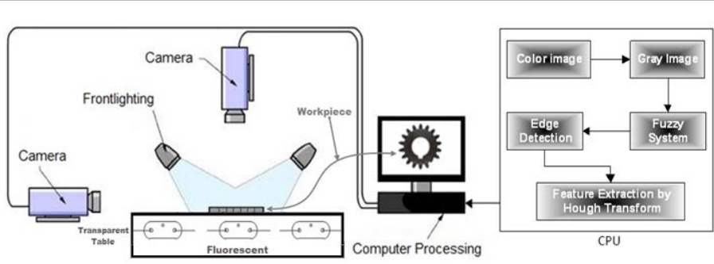
Figure 3:Computer vision system

MATERIAL
The object used is a mechanical part which was manufactured without having CAD model as shown in figure 4. So, we scanned this object by using a scanner and Artec Studio 12 Professional software. Then we used Geomagic Design X to get the CAD model for it.

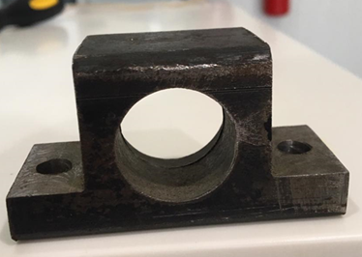
Figure 4:Mechanical component

MACHINE DESCRIPTION

Artec Studio 12 Professional
The software and machine used for scanning are Artec Studio 12 Professional software and Artec Scanner. The Artec scanner as shown in Figure 5 is a non-contact scanner type, which capture every details and frames of the object and send it to Artec Studio 12 Professional software. Artec Studio is an industry-acclaimed software package for advanced 3D scanning and data processing, It enables you to scan countless objects using Artec scanners. These artec scanners and software’s have high precision and they are built with powerful technologies that process your data very fast.

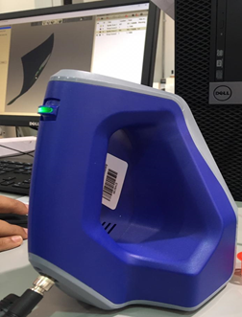
Figure 5:Artec Scanner

Geomagic Design X
The software used for converting the scanning data into a CAD model is the Geomagic Design X software. Geomagic Design X is a software used for converting 3D scan data into high-quality CAD models. It does it has a greet accurate exact surface fitting to organic 3D scans, mesh editing and point cloud processing. In addition, its easy to use for making the final CAD model.

METHODOLOGY
As mentioned above, the purpose of this report is to use reverse engineering process to find and the CAD model for our mechanical part. In this section, we will explain what we did to get the CAD model.

Scanning
We are going to scan a mechanical object which has a complicated geometry and some surfaces. Our piece is small which is illustrated in the Figure 4 which we have scanned by the Artec Scanner. After the scanning, we used the Artec software which scanning data goes there and we edit it and fix some surfaces and remove some unnecessary frames to make the scanned part good and prepare it for Geomagic Design X software. After we finished, we saved our work as stl file so that we can use it for Geomagic Design X software.

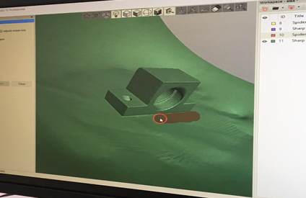
Figure 6:Artec software

Design the CAD Model
After the scanning, we import the stl file to Geomagic Design X software to draw and design our part. We are starting the procedure to convert the 3D Scanner in a solid 3D cad model. The idea is to draw a solid taking advantage of the mesh. At the end, the 3D solid must look like the mesh. Other thing is that reverse engineering is always an approximation of the original piece, in other words, at the end our piece will be approximately the same as the original piece. And then, we can get our 3D-CAD model by Catia or other software.

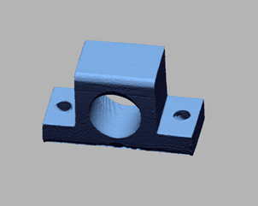
Figure 7: Point cloud data

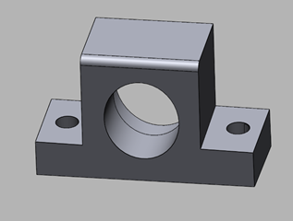
Figure 8: CAD model

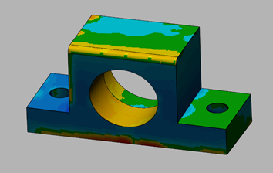
Figure 9: measurement and comparison by use the Accuracy Analyzer between the Solid and CAD model with its source scan

At the End, we got our CAD model, and from it we can have the dimensions and other specification that we didn’t have at first. And, from the CAD model we manufacture the part as much as we want.

CONCLUSION
The case studied has permitted us to discover how the reverse engineering can be useful for manufacturing already existing pieces. In this report we showed how a 3D scanner works and its applications in the reverse engineering field. We showed how to get data from the objects with the scanner. Also, with different software we could repair the mesh, orientate it and define the position of the mesh.

REFERENCES

[1] | A. V. M. B. B. A. V. N. Chougule, "Development of patient specific implants for Minimum Invasive Spine Surgeries (MISS) from non-invasive imaging techniques by reverse engineering and additive manufacturing techniques," Procedia Engineering, no. 97, pp. 212-219, 2014.
[2] | Z. Xia, "Application of Reverse Engineering based on Computer in Product design," International Journal of Multimedia and Ubiquitous Engineering, vol. 9, no. 5, pp. 343-354, 2014.
[3] | P. H. J. S. V. A. N. A. Antonio Piratelli-Filho, "Study of Contact and Non-contact Measurement Techniques Applied to Reverse Engineering of Complex Techniques Applied to Reverse Engineering of Complex," International Journal of Mechanical Engineering and Automation , vol. 1, no. 3, pp. 166-175, 2014.
[4] | G. S. Reddy, "Experimental Investigation on Reverse Engineering of a Typical Freeform Surface using Portable Laser Arm Scanner," International Journal of Current Engineering and Technology, vol. 6, no. 5, pp. 126-131, 2016.
[5] | T. BABU, "Reverse Engineering, CAD\CAM & pattern less process applications in casting-A case study," INTERNATIONAL JOURNAL OF MECHANICS, vol. 5, no. 1, pp. 40-47, 2011.
[6] | A. A. Alshennawy, "A Reverse Engineering Technique for Reproducing Spare Parts using Computer Vision System," International Journal of Scientific & Engineering Research, vol. 5, no. 10, pp. 1033-1038, 2014.
[7] | S. o. C. a. N.c. M. T. A. t. R. E. o. C. F. Parts, "Antonio Piratelli-Filho," International Journal of Mechanical Engineering and Automation.

