**A STEP-UP RESONANT CONVERTER FOR VERTICAL AXIS WINDWILL**

**A.Rajesh, Assistant Professor,SCAD college of Engineering and Technology**

**R.Jeba Raj, Assistant Professor,SCAD college of Engineering and Technology**

**C.Pon Nirmal , Assistant Professor,SCAD college of Engineering and Technology**

**R.Arul Jose , Assistant Professor,SCAD college of Engineering and Technology**

***Abstract*-The Demand on electricity is much higher than that of its production. This paper provides to produce the electricity by using the force of air by means of electrical axis wind mill. With the rapid development of large scale renewable energy sources and HVDC grid ,it is a promising option to connect the renewable energy sources to the HVDC grid with pure DC system , in which high-power , high –voltage step- up DC-DC converters are the key equipment to transmit the electrical energy. This paper proposes a resonant converter which is suitable for grid-connected renewable energy sources. The converter can achieve high voltage gain using LC parallel resonant tank. It is characterized by zero-voltage-switching (ZVS) turn-on and nearly ZVS turn-off of main switches as well as zero-current- switching(ZCS) turn-off of rectifier diodes, moreover the equivalent Voltage stress of the semiconductor devices is lower than other resonant step up converters.**

***Index Terms*- Vertical axis wind mill, Boost converter, LC parallel resonant tank , ZVS, ZCS**

1. **INTRODUCTION**

In renewable energy field sector the windmill plays an important role in energy production. The horizontal axis windmill might not be implemented in our normal surroundings. As it is not suitable for all wind direction and it gives partial efficiency and also increase in cost of design, installation, and maintenance. To overcome all these problems a new unique method of windmill (vertical axis windmill) is to be introduced. This paper have kept one step forward of windmill technology with use full application. The main aim of this project paper is to produce energy by using renewable energy resources in that manner the wind is very much eco friendly and very compactable one. By using that energy in a useful manner we can produce a continuous power. This vertical axis windmill is a new method which overcomes the previous windmill problems. By adjusting the windmill blade it suit itself with efficient energy generation in all direction. The main advantage of vertical axis windmill is it can generate power in all direction of wind flow. And the other advantages are the maintenance is less and the height of the tower is less. The development of renewable energy sources is crucial to relieve the pressures of exhaustion of the fossil fuel and environmental pollution. At present, most of the renewable energy sources are utilized with the form of AC power. The generation equipments of the renewable energy sources and energy storage devices usually contain DC conversion stages and the produced electrical energy is delivered to the power grid through DC/AC stages, resulting in additional energy loss.

Moreover, the common problem of the renewable energy sources, such as wind and solar, is the large variations of output power, and the connection of large scale of the renewable sources to the power grid is a huge challenge for the traditional electrical equipment, grid structure, and operation. DC grid, as one of the solutions to the afore mentioned issues, is an emerging and promising approach which has been drawn much attention recently. At present, the voltages over the DC stages in the generation equipments of the renewable energy sources are relatively low, in the range of several hundred volts to several thousand volts, hence, high-power high-voltage step-up DC-DC converters are required to deliver the produced electrical energy to HVDC grid. Furthermore, as the connectors between the renewable energy sources and HVDC grid, the step-up DC-DC converters not only transmit electrical energy, but also isolate or buff kinds of fault conditions, they are one of the key equipments in the DC grid. Recently, the high-power high-voltage step-up DC-DC converters have been studied extensively. The transformer is a convenient approach to realize voltage step-up. The classic full-bridge (FB) converter, single active bridge (SAB) converter, and LCC resonant converter are studied and their performance is compared for the offshore wind farm application. The three phases topologies, such as three-phase SAB converter, series resonant converter and dual active bridge (DAB) converter, which are more suitable for high-power applications due to alleviated current stress of each bridge, are also studied and designed for high-power high voltage step-up applications. Multiple small-capacity isolated converters connected in series and/or parallel to form a high-power high-voltage converter is an effective means to avoid the use of single large-capacity transformer.

**WIND ENERGY**

The kinetic energy of the wind can be changed into other forms of energy either mechanical energy or electrical energy. The extraction of energy from Wind, especially in the form of Electricity, has enjoyed renewed interest among both utilities and government’s Wind energy is the fastest growing Form of energy today, up to 400% increase in the past 20 years. Today, there are over 30,000 Wind turbines worldwide, with an installed capacity of Over 40,000 MW. Wind power’s environmental Impact is almost insignificant, its main problem being visual “pollution,” although concerns about noise, communications Interference have been expressed. Wind speed and direction are measured by an anemometer.

**II. EXISTING SYSTEM**

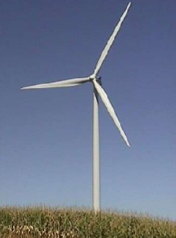**HORIZONTAL AXIS WIND MILL**

**Fig. 1. Horizontal Axis wind mill**

The present design of Horizontal axis windmill might not be implemented in our normal surroundings. As it is not suitable for all wind direction and it gives partial efficiency and also increase in cost of design, installation, and maintenance .and it has need a yaw system and control system is also required. this windmill tower height is high compared to vertical axis windmill.

**HORIZONTAL AXIS WIND TURBINE (HAWT)**

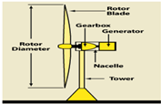

**Fig. 2. Horizontal Axis Wind Turbines**

To accomplish this task efficiently, especially for large HAWT, active pitch controllers are used to ensure that each blade is adjusted to maintain an optimal angle of attack for maximum power extraction for a given wind speed. A yaw controller is also used to actively yaw the blades into the wind. However, these active control systems are complex and require more moving parts and effort to install than a VAWT assembly where the only moving part is the rotor, and the majority of components are located at the base of the turbine The design and manufacturing of a HAWT blade is complex as the blade is tapered and twisted with varying cross-sections in order to achieve optimum aerodynamic performance.

The design and manufacturing of a HAWT blade is complex as the blade is tapered and twisted with varying cross-sections in order to achieve optimum aerodynamic performance. The change in the cross-section and twist of the blade from the root to the tip is due to the variation of the relative velocity component. Because the tip of the blade spins much faster than the root, the twist of the blade is shallow and the cross-section is thin. It can be seen due to the high relative velocity at the tip, the resultant force F acting on the blade section is extremely high, but only a small portion of that force Fd is driving the rotation. However, because of the blades design, the thin blade profile with a low angle of twist at the tip produces roughly the same amount of torque as the root of the blade due to its large moment arm.

This design means a larger portion of the resultant force is in the direction of rotation. However, due to the lower moment arm at the root, the torque distribution over the entire blade is fairly uniform.

**III. PROPOSED SYSTEM**

**BLOCK DIAGRAM**

**Fig. 3. Block Diagram of Vertical Axis Windmill**

**VERTICAL AXISWINDMILL**

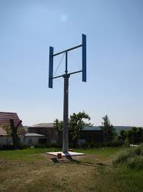

**Fig. 4. Vertical Axis Windmill**

**VERTICAL AXIS WIND TURBINES**

Vertical-axis wind turbinesare a type of wind turbine where the main rotor shaft is set vertically. Among the advantages of this arrangement are that generators and gearboxes can be placed close to the ground, and that VAWT do not need to be pointed into the wind. Major drawbacks for the early designs(Savonius,Darrieus, giromilland,cycloturbine) included the pulsatory torque that can be produced during each revolution and the huge bending moments on the blades. Later designs solved the torque issue by using the helical twist of the blades almost similar to Gorlov's water turbines.

* **DESIGN METHODOLOGY**

This design methodology is to increase the efficiency of the windmill at first the designing steps starts with the design of windmill blades. Because this blades will mainly affects the overall efficiency of the windmill. For a particular application the wind mill blade should be in required size. Before this getting knowledge about the aerodynamic style of windmill blade in order to get the full efficiency is very much important. The various considerations are.

**A. WIND SPEED**

The speed of the wind is very much important for the production of electricity in the windmill. Because in windmill we are using the wind as a raw material for the power production this bakes the axis rotate and this axis is coupled with a dc generator and makes its also rotate and produce electricity.

**B. TOWER HEIGHT AND DESIGN**

The height of the tower is very much important for a windmill. In VAHW the tower is kept little sort to obtain whole air density passing from the vehicle We also should concentrate in the design of the tower because it should able to withstand for its own weight and also in the speed of the wind

**C. SHAPE OF THE BLADE**

As discussed earlier the shape of the wind mill blades is the important one if one could place an efficient design of a blade then the efficiency of the windmill will be increased. The various windmill shapes are as follows;



**Figure 5 Diagram Of Blade Rotation**

a) Flat, unmodified blade surface.

b) wing shape with one leading edge

c) Both edges tapered to a thin line.

d) Both edges leading blade

The shape blades are provided below

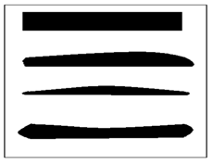

Fig 6.Shapes of blades

**D. GENERATOR**

An electric generatoris a device that converts mechanical energy to electrical energy. The reverse conversion of electrical energy into mechanical energy is done by a motor; motors and generators have many similarities. A generator forces electrons in the windings to flow through the external electrical circuit. It is somewhat analogous to a water pump, which creates a flow of water but does not create the water inside. The source of mechanical energy may be a reciprocating or turbine steam engine, water falling through a turbine or waterwheel, an internal combustion engine, a wind turbine, a hand crank, compressed air or any other source of mechanical energy.**.**



**Fig. 7. Generator**

**HIGH STEP-UP RESONANT CONVERTER**

**4.1 CONVERTER STRUCTURE**

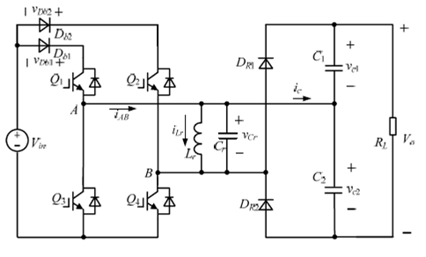

**Fig. 8. Converter Structure**

The proposed resonant step-up converter is shown in Fig. 1. The converter is composed of a full-bridge switch network, which is made up by *Q*1 through *Q*4, a LC parallel resonant tank, a voltage doublers rectifier and two input blocking diodes, *Db*1 and *Db*2. For the proposed converter, *Q*2 and *Q*3 are tuned on and off simultaneously, *Q*1 and *Q*4 are tuned on and off simultaneously. In order to simplify the analysis of the converter, the following assumptions are made:

1) All switches, diodes, inductor and capacitor are ideal components;

2) Output filter capacitors *C*1 and *C*2 are equal and large enough so that the output voltage *Vo* is considered constant in a switching period *Ts*.

**4.2 MODES OF OPERATION**

**Mode1**

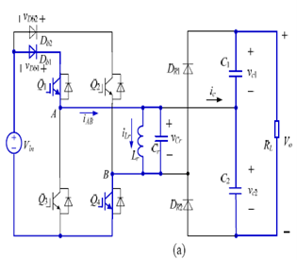

**Mode 2**



**Mode3**



**Mode 4**



**Mode5  
**

**Fig. 9. Equivalent circuits of each operation stages**

1. **Mode 1 [*t*0, *t*1]**

* During this mode, *Q*1 and *Q*4 are turned on resulting in the positive input voltage *Vin* across the LC parallel resonant tank, i.e., *VLr*=*VCr*=*Vin*.
* The load is powered by *C*1 and *C*2. At *t*1, the resonant inductor current *ILr* reaches I*1*.

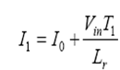

where *T*1 is the time interval of *t*0 to *t*1.

 In this mode the energy delivered from *Vin* to *Lr* is

1. **Mode 2 [*t*1, *t*3]**

* At t1, Q1 and Q4 are turned off and after that Lr resonates with Cr, VCr

decrease from Vin and ILr increases from I1 in resonant form.

* The voltage across Q1 is kept at Vin. The equivalent circuit of the converter after t2 is shown in Fig, in which D2 and D3 are the anti-parallel diodes of Q2 and Q3, respectively.
* This mode runs until VCr increases to -Vo/2 and ILr reduces to I2, at t3, the voltage across Q4 reaches Vo/2 and the voltage across Db2 reaches Vo/2-Vin.

**(3) Mode 3 [*t*3, *t*4]**

* At *t*3, *VCr* =-*Vo*/2, *DR*1 conducts naturally, *C*1 is charged by *ILr* through *DR*1, *VCr* keeps unchanged, *ILr* decreases linearly.
* At *t*4, *ILr* =0. The time interval of *t*3 to *t*4 . Assuming 100% conversion efficiency of the converter and according to the energy conversation rule, in half switching period.

**(4) Mode 4 [*t*4, *t*5]**

* At *t4, ILr* decreases to zero and the current flowing through *DR1* also decreases to zero, and DR1 is turned off with zero-current-switching (ZCS), therefore, there is no reverse recovery.
* After *t4, Lr* resonates with *Cr, Cr* isdischarged through *Lr, VCr* increases from *-Vo/2* in positive direction, *ILr* increases from zero in negative direction.
* Meanwhile, the voltage across *Q4* declines from *Vo/2. At t5, VCr = -Vin, ILr= -I3.*

**(5) Mode 5 [*t*5, *t*6]**

* If *Q2 and Q3* are turned on before *t5*, then after *t5, Lr* is charged by *Vin* through *Q2 and Q3, ILr* increases in negative direction, the mode is similar to Mode 1
* If *Q2* and *Q3* are not turned on before *t5,* then after *t5, Lr* will resonate with *Cr,* the voltage of node *A VA* will increase from zero and the voltage of node *B VB* will decay from *Vin,* Zero-voltage condition will be lost if *Q2* and *Q3* are turned on at the moment.

**OUTPUT WAVEFORMS**



**Fig. 10 Output waveform**

**SIMULATION OF PROPOSECONVERTER**

In order to verify the operation principle and the theoretical analysis, a converter is simulated with PLECS simulation software and the detailed parameters are listed in Table .All switches using in PLECS simulation are ideal switches and 5 nF capacitance is added in parallel with *Db*1 and *Db*2.

A step up resonant converter is a DC-DC power converter with an output voltage greater than its input voltage and at least one energy storage element, a capacitor, inductor, or the two combinations. filters made of capacitors are normally added to the output of the converter to reduce output voltage ripple. The simulation diagram for step up resonant converter is shown figure 11.

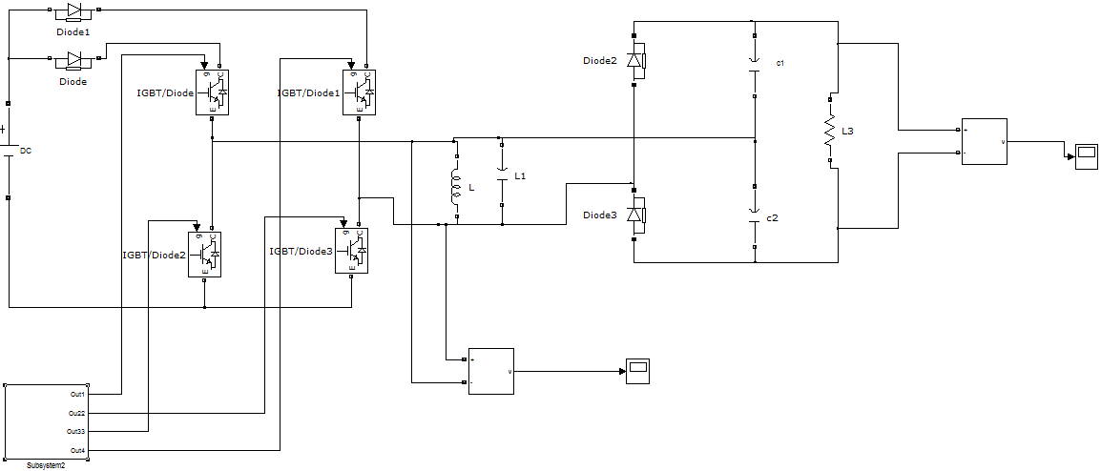**Fig. 11. Step Up Resonant Converter**

**SIMULATION OF OUTPUT VOLTAGE AND CURRENT**

The output waveform of the step up resonant converter. Here the input voltage is 4KV DC supply is given. Converter performs the boost up the obtained voltage to 56KV.

**Fig.12.Simulation Of Output Voltage and Current**

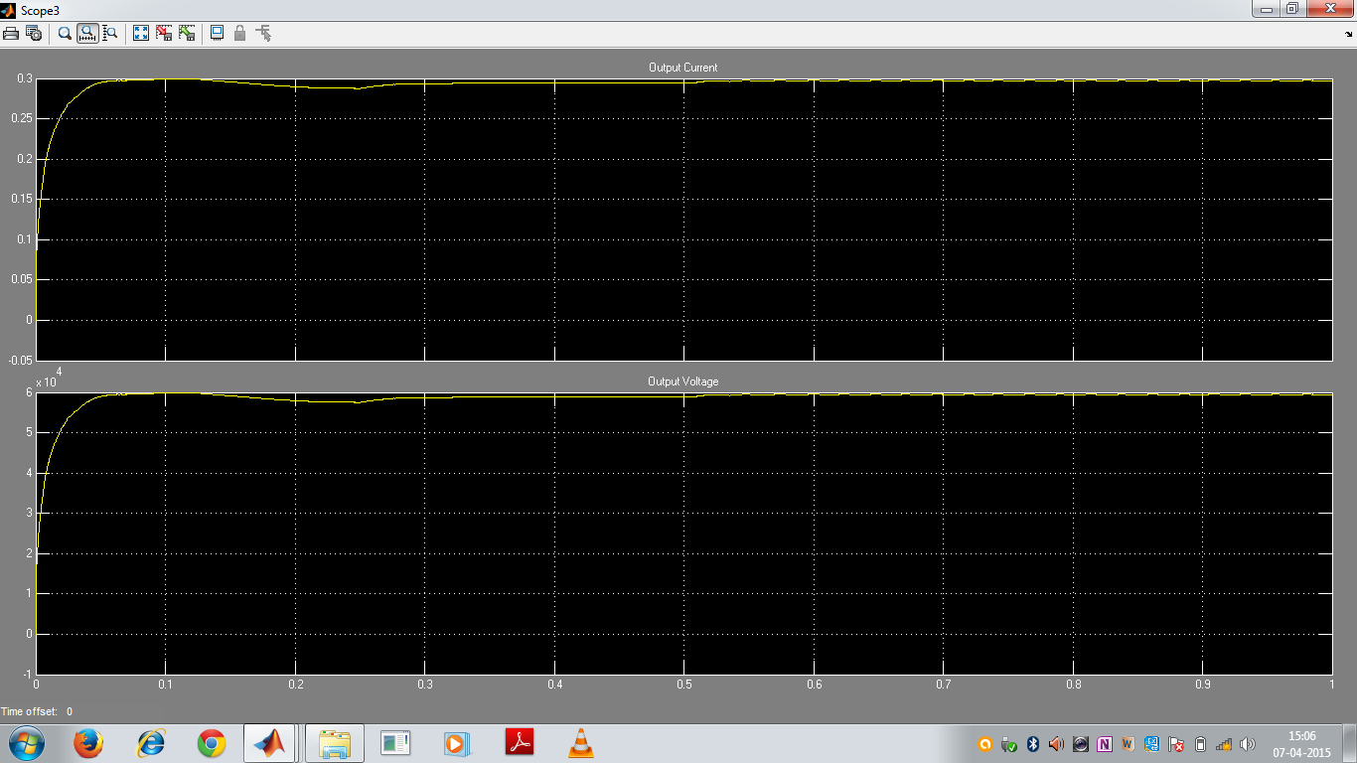

**SIMULATION OF INPUT VOLTAGE**

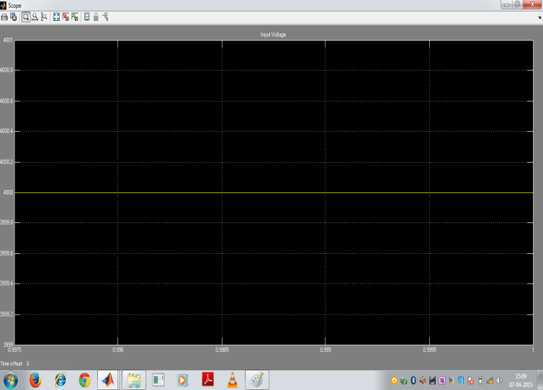

**Fig.13.Simulation of input voltage**

**SIMULATION OUTPUT OF FULL BRIDGE RECTIFIER**

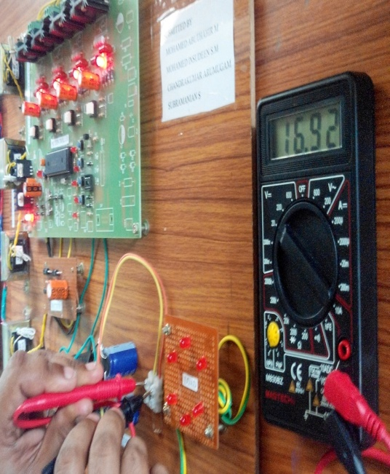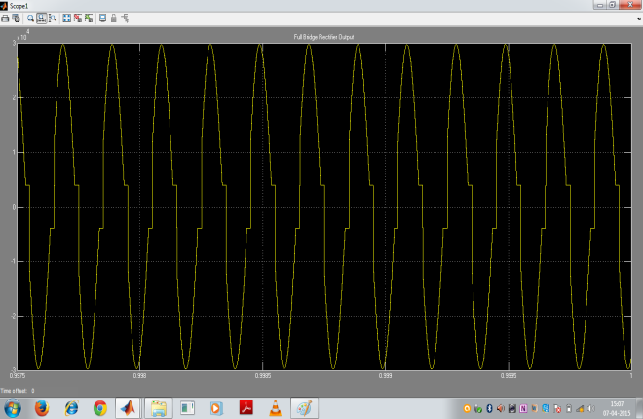

**Fig.14. Simulation Output Of Full Bridge Rectifier**

**HARDWARE PROTOCOL**

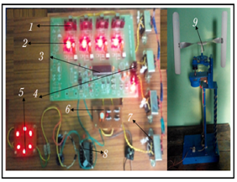

**Fig.15. Hardware setup**

**HARDWARE OUTPUT OF PROPOSED CONVERTER AND VAWM**

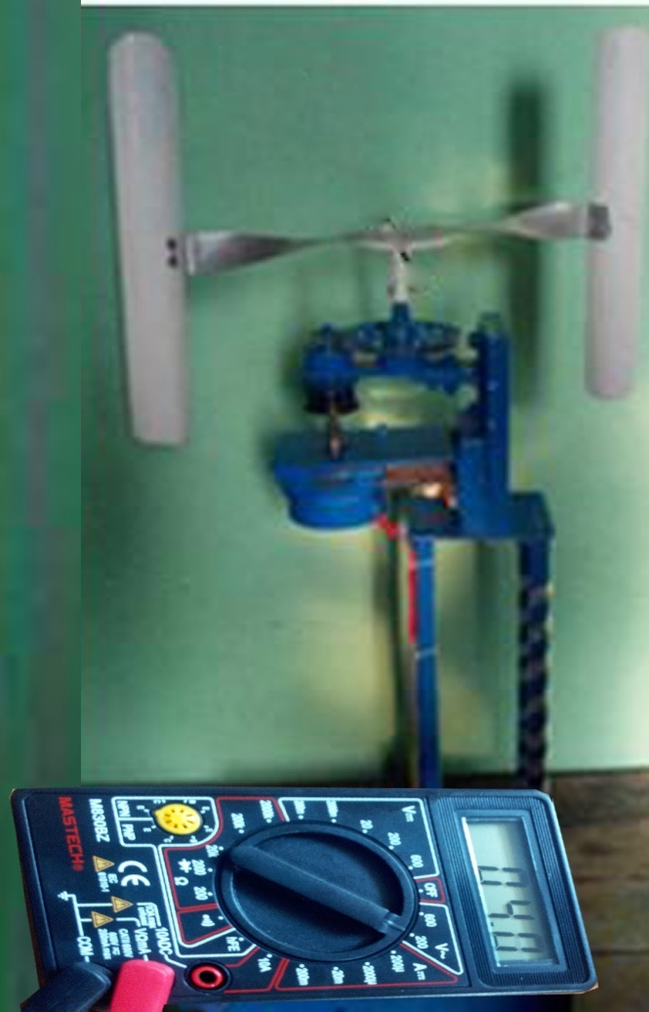

**Fig.15Hardware Output of Proposed Converter and VAWM**

**CONCLUSION**

This vertical axis windmill gives an idea about the new way of power generation and also about the new windmill technology. The power generation using Vertical axis wind mill is an eco-friendly method and power produced here is almost an continuous one .By using this technology all the apartments can be lightened without use of non- renewable energy resources’. And if this method is implemented in all apartments we can able to produce large amount of power and it can also provide job for many educated fellowship and also A novel resonant DC-DC converter is proposed in this paper, which can achieves very high step-up voltage gain and it is suitable for high-power high-voltage applications. The converter utilizes the resonant inductor to delivery power by charging from the input and discharging to the output.

The resonant capacitor is employed to achieve zero-voltage turn-on and turn-off for the active switches and ZCS for the rectifier diodes. The analysis demonstrates that the converter can operate at any gain value (>2) with proper control, however, the parameters of the resonant tank determine the maximum switching frequency, the range of switching frequency and current ratings of active switches and diodes. The converter is controlled by the variable switching frequency. Simulation and experimental results verify the operation principle of the converter and parameters selection of the resonant tank.

**REFERENCES**

[1] CIGRE B4-52 Working Group, “HVDC grid feasibility study,” Melbourne: International Council on Large Electric Systems, 2011.

[2] A. S. Abdel-Khalik, A. M. Massoud, A. A. Elserougi, andS. Ahmed , “Optimum power transmission-based droop control design for multi-terminal HVDC of offshore wind farms,” *IEEE Trans. Power Syst.*, vol. 28, no. 3, pp. 3401–3409, 2013.

[3] F. Deng and Z. Chen, “Design of protective inductors for HVDC transmission line within DC grid offshore wind farms,” *IEEE Trans. Power Del.,* vol. 28, no. 1, pp. 75–83, 2013.

[4] F. Deng and Zhe Chen, “Operation and control of a DC grid offshore wind farm under DC transmission system faults,” *IEEE Trans. Power Del.,* vol. 28, no. 1, pp. 1356–1363, 2013.

[5] C. Meyer, “Key components for future offshore DC grids,” PhD Thesis, RWTH Aachen University, 2007.

[6] W. Chen, A. Huang, S. Lukic, et al, “A comparison of medium voltage high power DC/DC converters with high step-up conversion ratio for offshore wind energy systems,” *in Proc. IEEE ECCE*, 2011, pp. 584–589

[7] H. Keyhani and H. A. Toliyat, “Isolated ZVS high frequency-link AC-AC converter with a reduced switch count,” *IEEE Trans. Power Electron.,* vol. 29, no. 8, pp.4156–4166, 2014.

[8] S.-H. Ahn, H.-J. Ryoo, J.-W. Gong, and S.-R. Jang ,“Design and test of a 35-kJ/s high-voltage capacitor charger based on a delta-connected three-phase resonant converter,” *IEEE Trans. Power Electron.,* vol. 29, no. 8,pp. 4039–4048,

2014.