JOURNAL ARTICLE FORMAT
Author name^{[1]}, Author name^{[2]}, Author name^{[3]}
Correspondence Authors (11pt Times New Roman, Bold, Center Aligned)
Correspondence Authors Designation, Department Collage, Country
(10pt Times New Roman, Center)

Abstract (12 Pts Times New Roman, Bold, Sentence case, Center Aligned)
An abstract of no more than 350 words (11pt Times New Roman).
Keywords: 4-8 Keywords are required (11pt Times New Roman, Italic)

- INTRODUCTION(12 Pts Times New Roman, Bold, Capital Letters, Left Aligned)
Page type normal A4. Normal spacing (single space between two sentences). In this introduction section paragraph space will be zero (no space between after and before paragraph). Introduction section all character size should be 11pt Times New Roman.

- SYSTEM MODELLING (12 Pts Times New Roman, Bold, Capital Letters, Left Aligned)
2.1 Subheadings (12 Pts Times New Roman, Sentence case Letters, Left Aligned)
- Sub- Subheadings(11 Pts Times New Roman, Sentence case Letters, Left Aligned)
- In this section all character size should be 11pt Times New Roman.

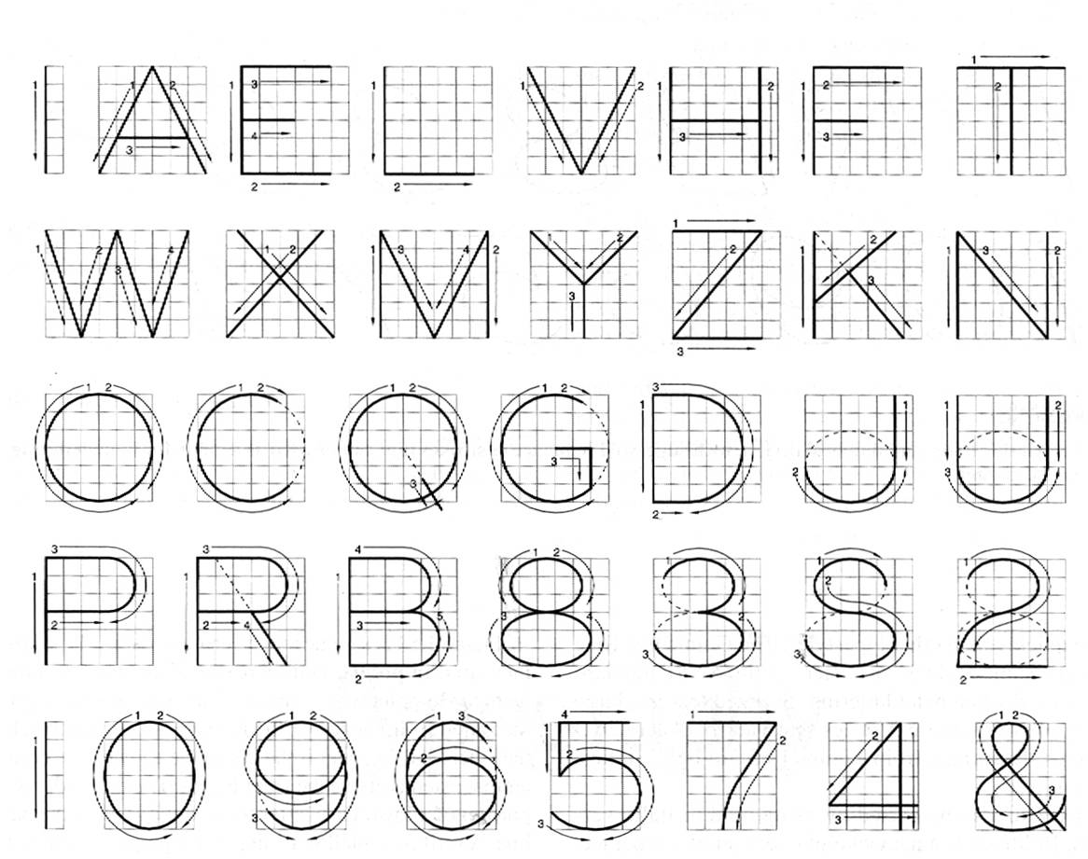
Figure 2.1: figure name
Figure name (10pt Times new roman, Italic)

- ALL OTHER SECTIONS (12 Pts Times New Roman, Bold, Capital Letters, Left Aligned)
3.1 Subheadings (12 Pts Times New Roman, Sentence case Letters, Left Aligned)
- Sub- Subheadings(11 Pts Times New Roman, Sentence case Letters, Left Aligned)

Equations and Formulae:
(1)
(2)

Tables: Table 3.1: Table name
INPUT A | INPUT B | OUTPUT C
0 | 0 | 0
1 | 0 | 1
0 | 1 | 1
1 | 1 | 1

- RESULT & DISCUSSION (12 Pts Times New Roman, Bold, Capital Letters, Left Aligned)
In this section all character size should be 11pt Times New Roman.

- CONCLUSION (12 Pts Times New Roman, Bold, Capital Letters, Left Aligned)
In this section all character size should be 11pt Times New Roman.

REFERENCES (12 Pts Times New Roman, Bold, Capital Letters, Left Aligned)
[1] D. O’Brien, R. Turnbull, H. L. Minh, G. Faulkner, O. Bouchet, P. Porcon, M. E. Tabach, E. Gueutier, M. Wolf, L. Grobe, and J. Li, "High-speed optical wireless demonstrators: Conclusions and future directions", Journal of Light wave Technology, Vol. 30, No. 13, pp. 2181–2187, Jul. 2012.
[2] J. Kahn and J. Barry, "Wireless infrared communications", In Proceedings of IEEE, Vol. 85, pp. 265–298, 1997.
[3] H. Elgala, R. Mesleh, and H. Haas, "Indoor optical wireless communication: Potential and state-of-the-art", IEEE Communication Magazine, Vol. 49, No. 9, pp. 56-62, 2011.
[4] L. Zeng, , D. O’Brien, H. Minh, G. Faulkner, K. Lee, D. Jung, Y. Oh, and E. T. Won, "High data rate multiple input multiple output (MIMO) optical wireless communications using white LED lighting", IEEE Journal of Selected Areas in Communication, Vol. 27, No. 9, pp. 1654-1662, 2009.
[5] H.B.C. Wook, T. Komine, S. Haruyama, and M. Nakagawa, "Visible light communication with LED-based traffic lights using 2-dimensional image sensor", In Proceedings of IEEE Conference on Consumer Communication Network, pp. 243-247, 2006.

